# Testing

First option list Tests

|  |  |  |  |
| --- | --- | --- | --- |
| **Picture** | **Input** | **Expected Outcome** | **Actual Outcome** |
| 1 | Keyboard | Enter some text | Enter some text |
| 2 | keyboardddddddd | Please re enter a valid option | Please re enter a valid option |
| 3 | Hi I am Lauren!!! | How would you like it to be displayed?  Table  Bar chart  Wordcount  Or Main Menu  Or Exit | How would you like it to be displayed?  Table  Bar chart  Wordcount  Or Main Menu  Or Exit |
| 4 | Demo | Demo sentence: #I Love Programming!!! | Demo sentence: #I Love Programming!!! |
| 5 | File input | Enter file name | Enter file name |
| 6 | Userinput.txt | How would you like it to be displayed?  Table  Bar chart  Wordcount  Or Main Menu  Or Exit | How would you like it to be displayed?  Table  Bar chart  Wordcount  Or Main Menu  Or Exit |
| 7 | userInputttttt/txt | The File could not be found  Re Enter a Valid File Name | The File could not be found  Re Enter a Valid File Name |

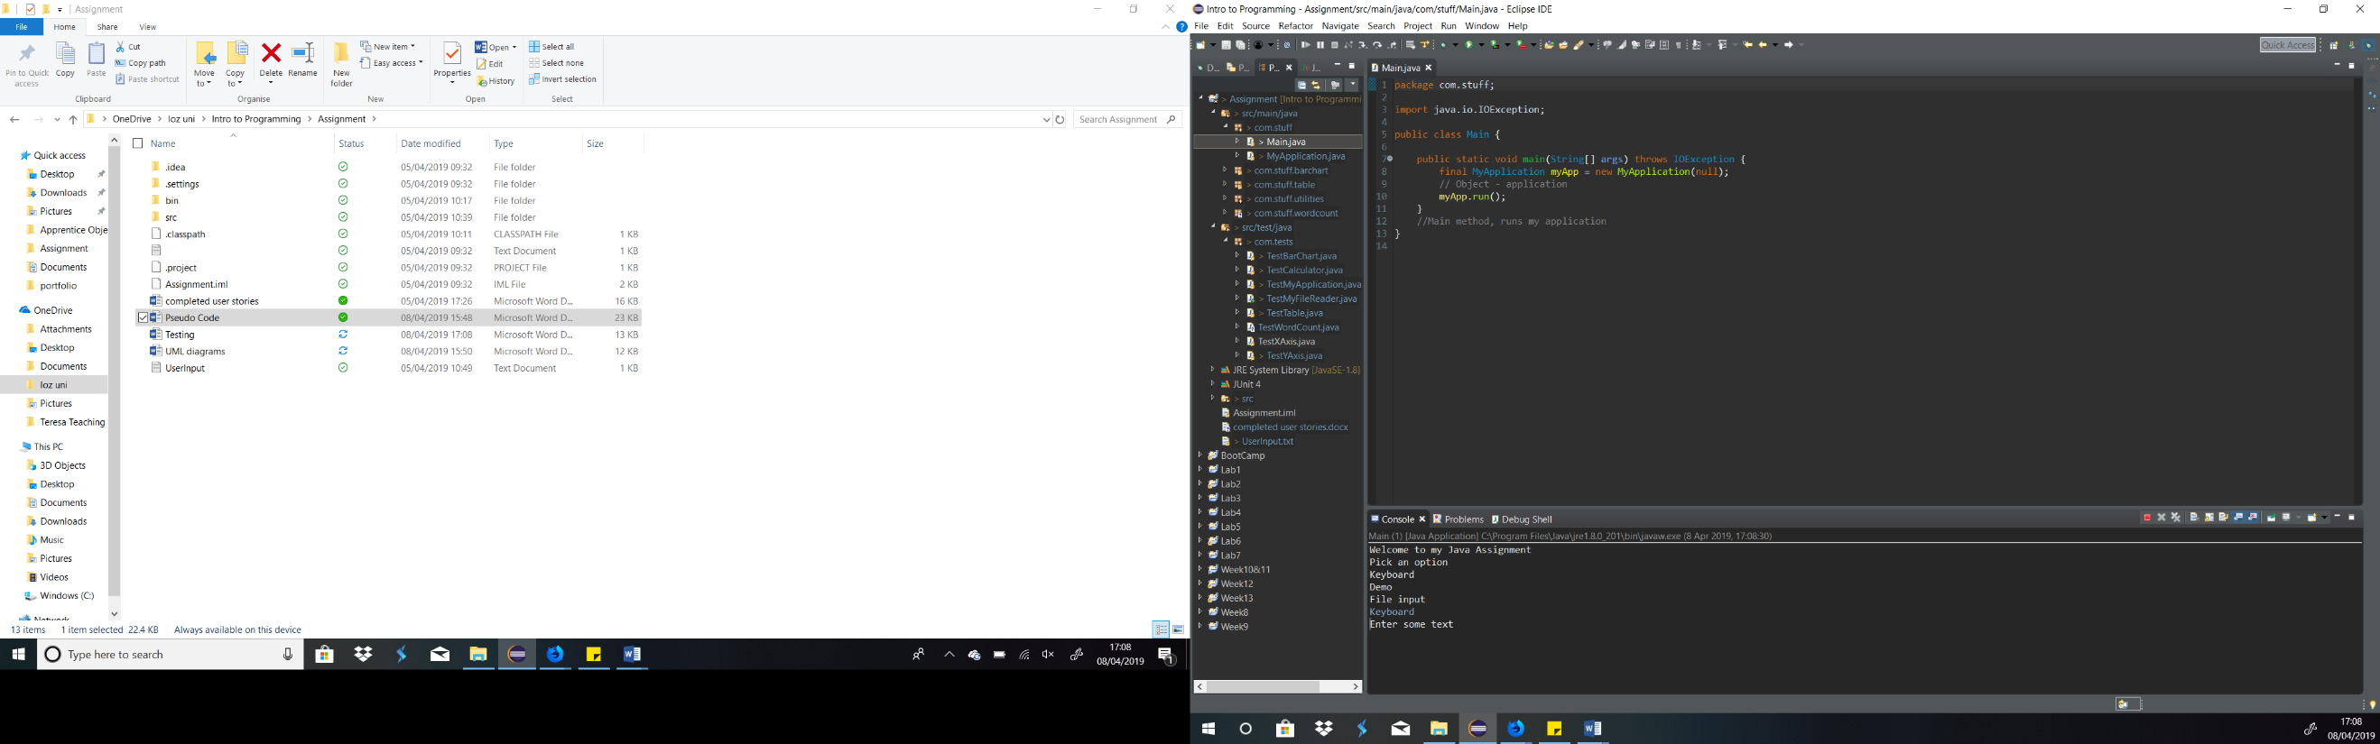

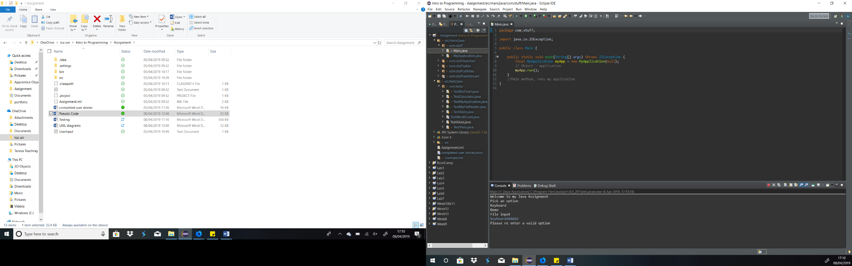

1. 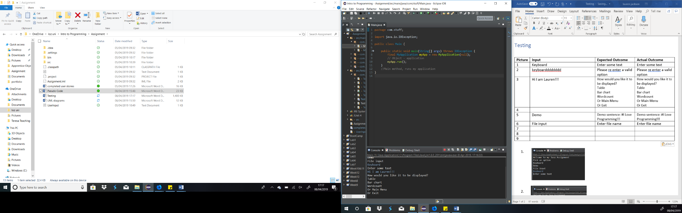

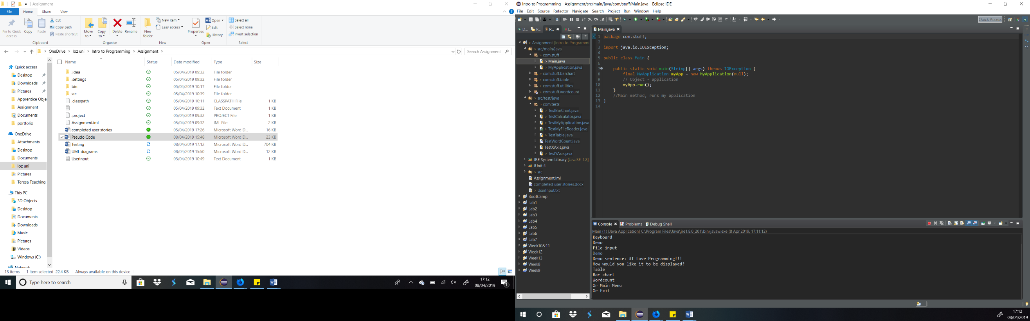

4.

1. 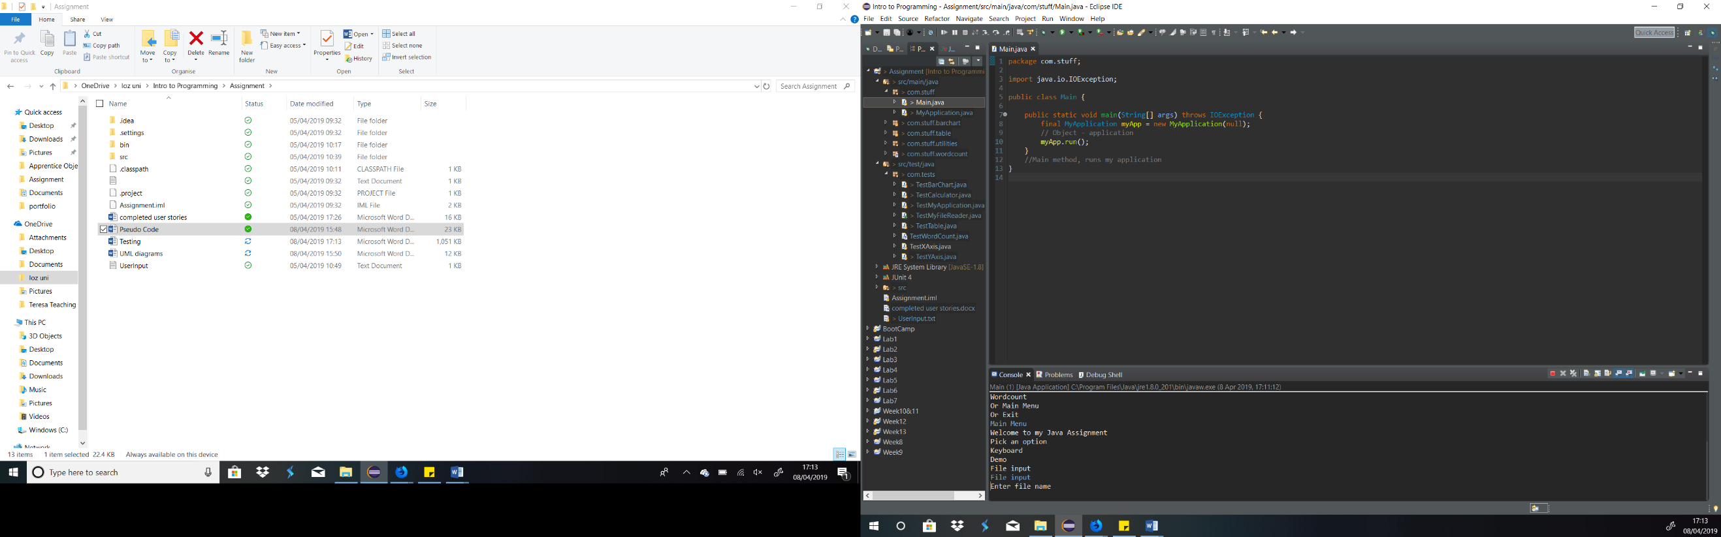

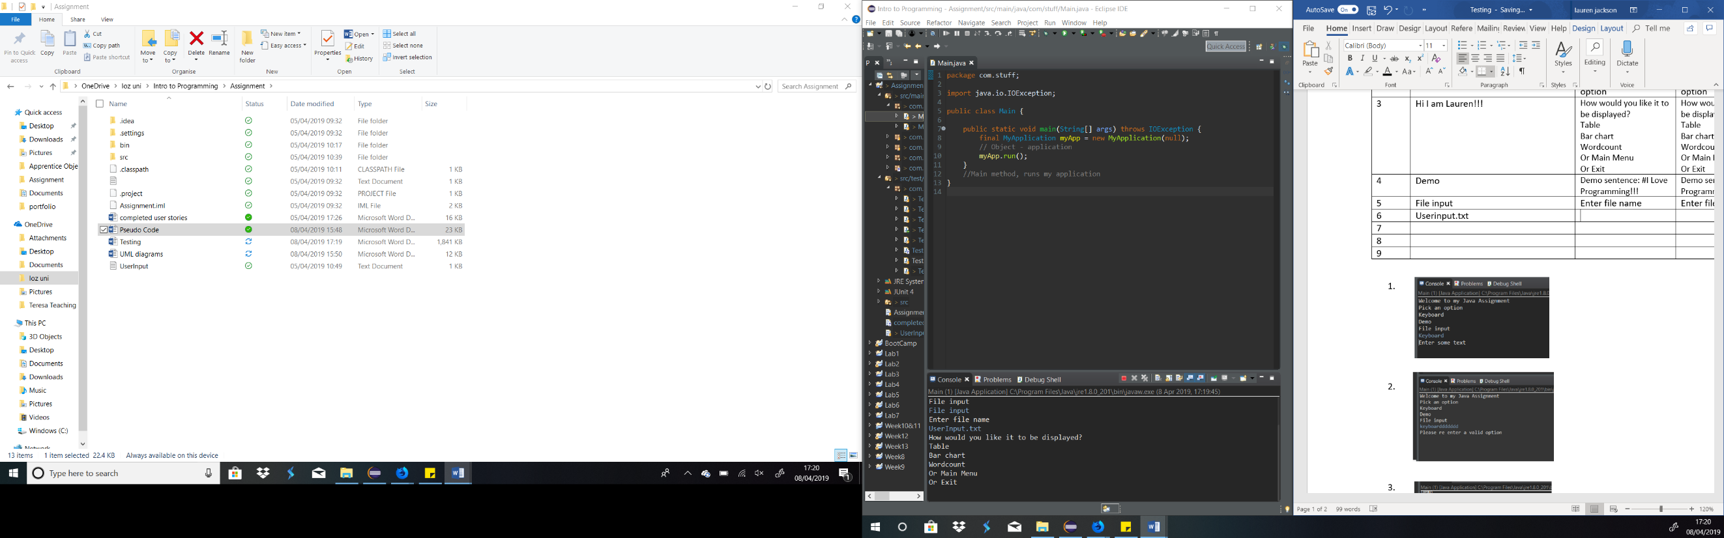

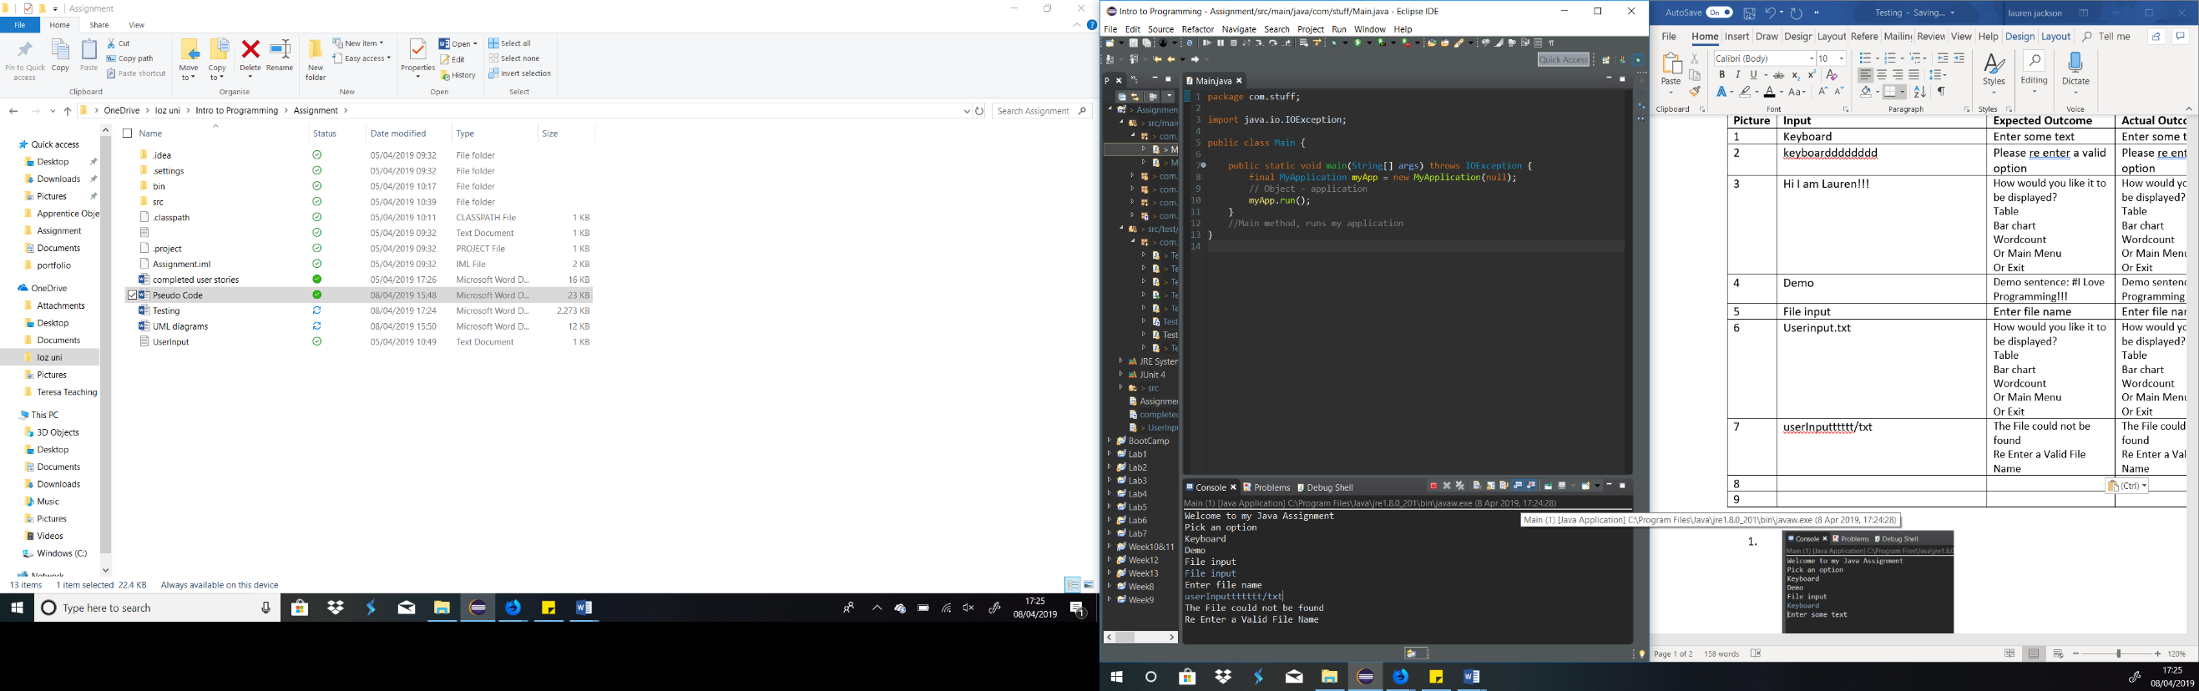

Second option list tests

|  |  |  |  |
| --- | --- | --- | --- |
| **Picture** | **Input** | **Expected outcome** | **Actual Outcome** |
| 1 & 2 | Table | Printed table | Printed table (see image 2) |
| 3 | Tableeee | Please re enter a valid option | Please re enter a valid option |
| 4 & 5 | Bar chart | Printed bar chart | Printed bar chart |
| 6 | Word count | Printed word count table | Printed word count table |
| 7 | Main Menu | Welcome to my Java Assignment  Pick an option  Keyboard  Demo  File input | Welcome to my Java Assignment  Pick an option  Keyboard  Demo  File input |
| 8 | Exit | Goodbye | Goodbye |

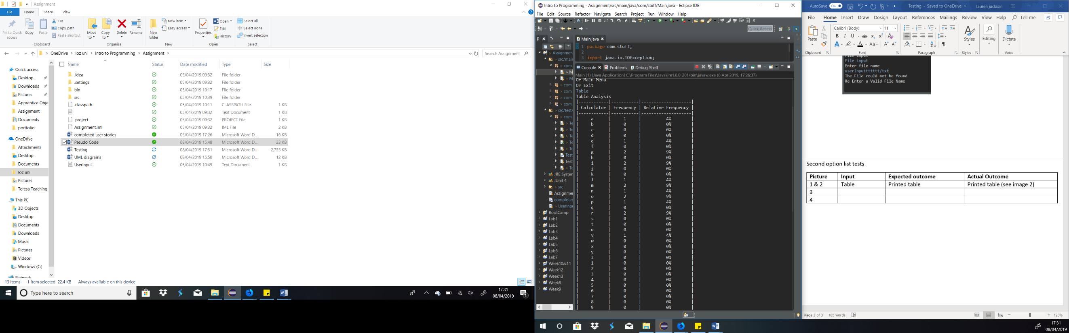

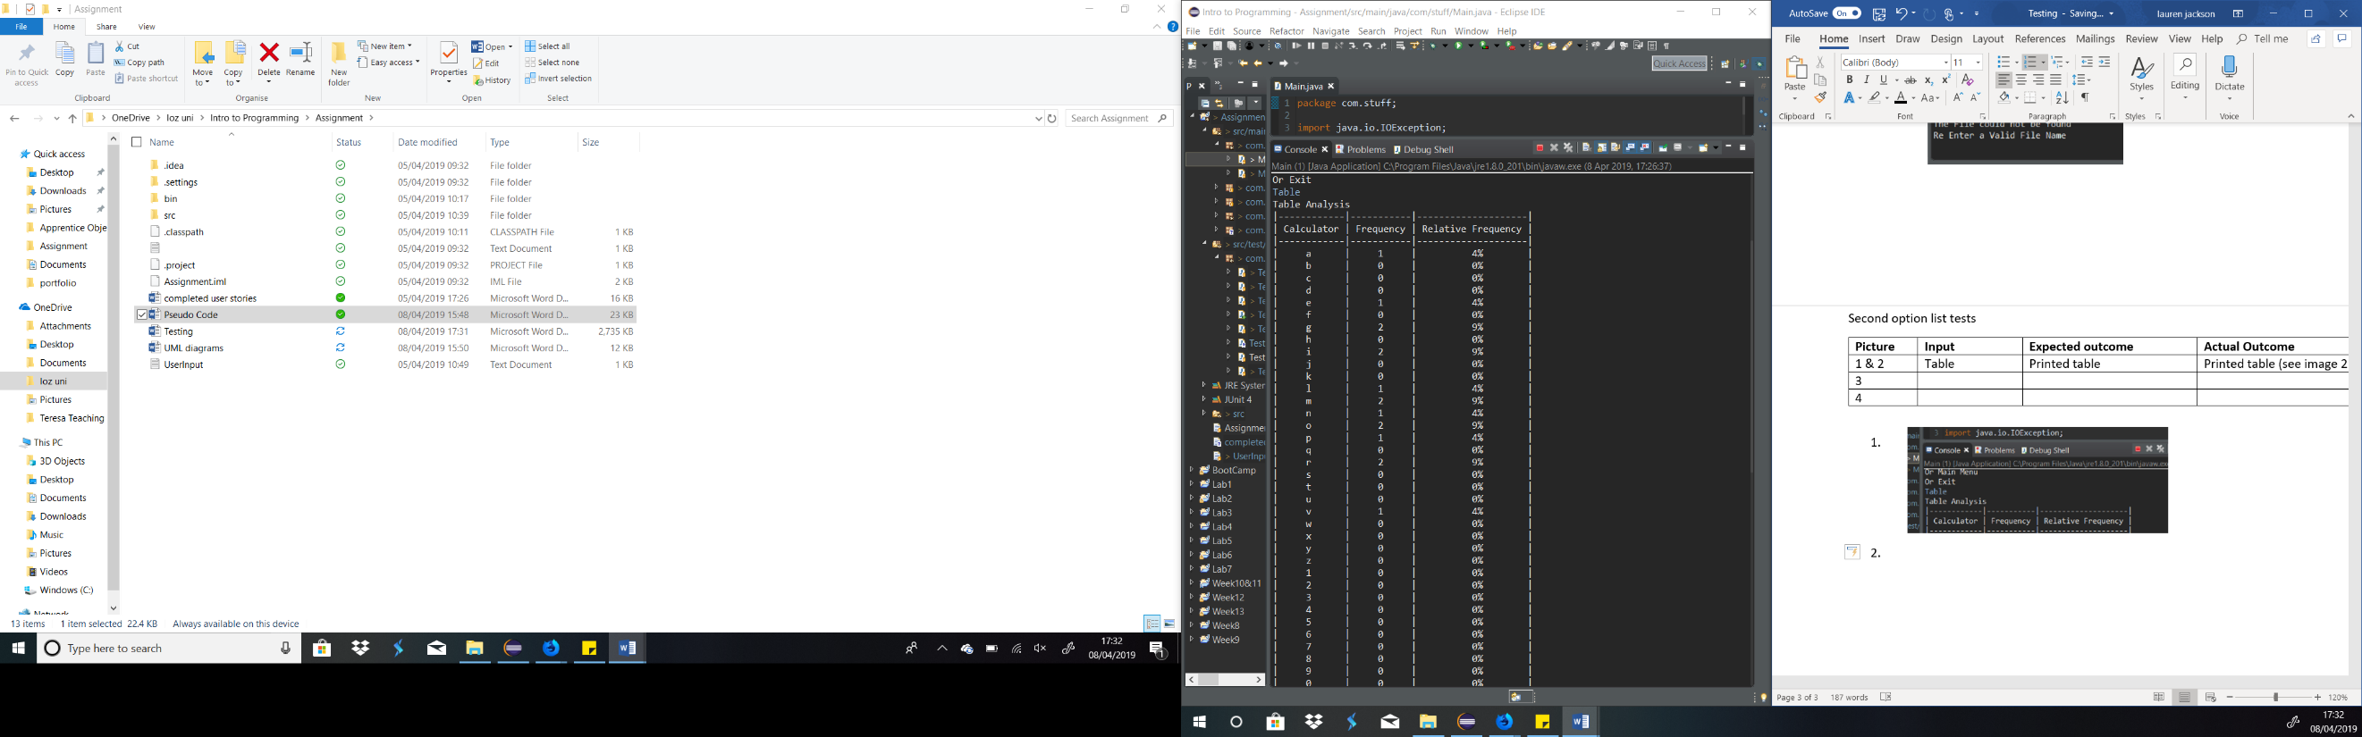

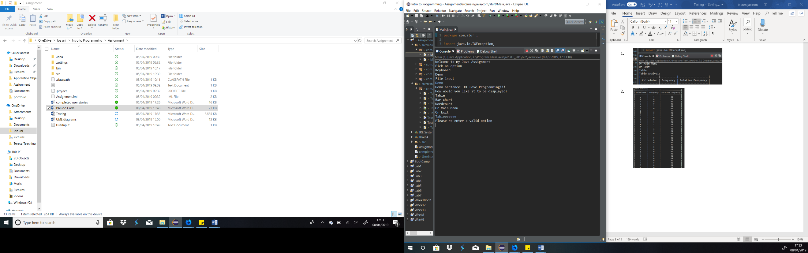

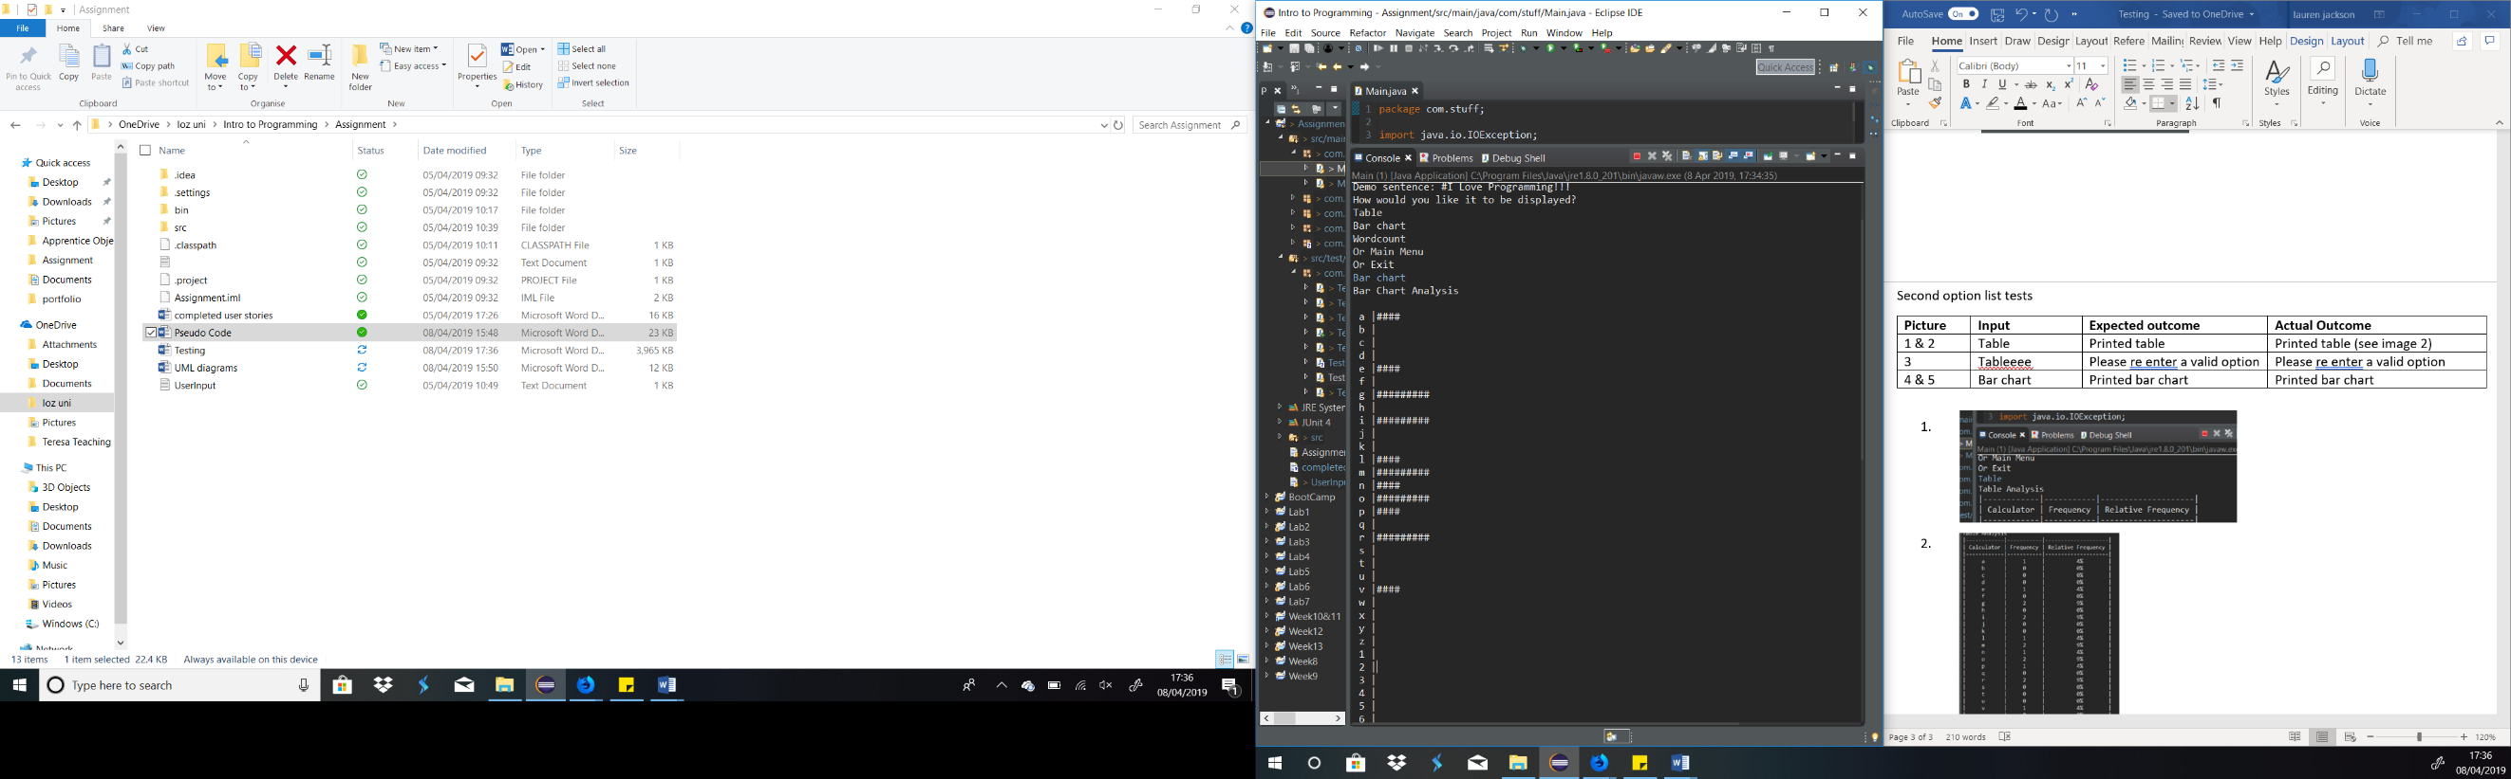

1. 